HIVE ASSIGNMENT   
  
FACEBOOK

CREATE DATABASE facebook_sk_db;

CREATE TABLE facebook (  
   userid INT,  
   age INT,  
   dob_day INT,  
   dob_year INT,  
   dob_month INT,  
   gender STRING,  
   tenure INT,  
   friend_count INT,  
   friendships_initiated INT,  
   likes INT,  
   likes_received INT,  
   mobile_likes INT,  
   mobile_likes_received INT,  
   www_likes INT,  
   www_likes_received INT  
)

ROW FORMAT DELIMITED FIELDS TERMINATED BY ','

LINES TERMINATED BY '\n'

STORED As TextFile

tblproperties(

"skip.header.line.count"="1"

);

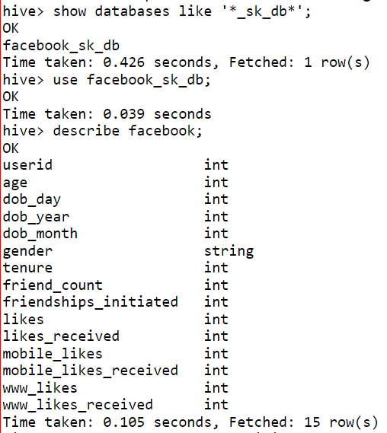



LOAD DATA LOCAL INPATH ‘home/mavricbdhnov0116/OneDrive_1_11-29-2023/Big Data DV Batch – Assignments/Datasets/Facebook/pseudo_facebook.csv’ INTO TABLE facebook_sk_db.facebook;

select count(*) as total_users from facebook_sk_db.facebook;

select count(*) as users_above_25 from facebook_sk_db.facebook where age > 25;

SELECT gender, count(friend_count) as avg_friend_count from facebook_sk_db.facebook group by gender;

select if (age <= 25, 'Young', 'Old') as age_group,sum(likes_received) as total_likes_received from facebook_sk_db.facebook group by if(age <= 25, 'Young', 'Old');

select dob_month, count(*) as user_count from facebook_sk_db.facebook group by dob_month;

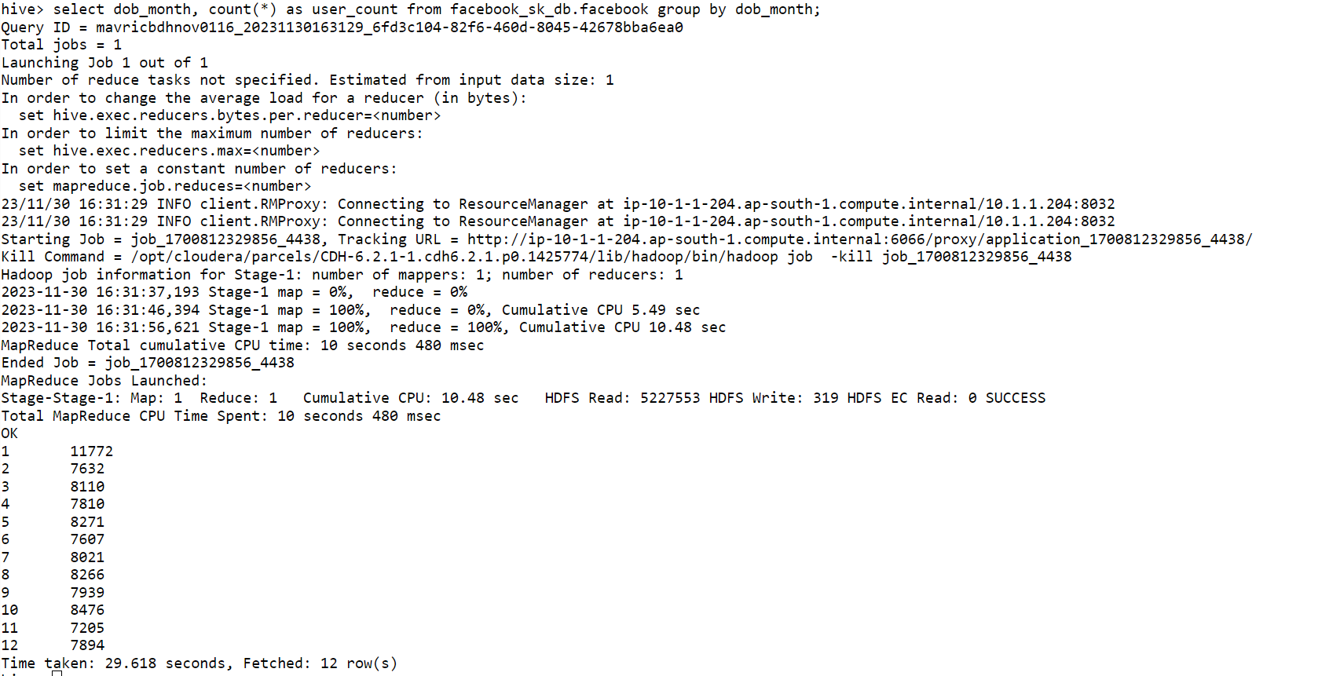

select 'Young' as age_group,SUM(mobile_likes) as mobile_likes,SUM(www_likes) as computer_likes FROM facebook_sk_db.facebook where age < 18 group by   'Young';

select 'Adult' as age_group,SUM(mobile_likes) as mobile_likes,SUM(www_likes) as computer_likes FROM facebook_sk_db.facebook where age >= 18 and age < 61 group by   ‘Adult’;

